Posted on May 17, 2018 by nysptaadmin
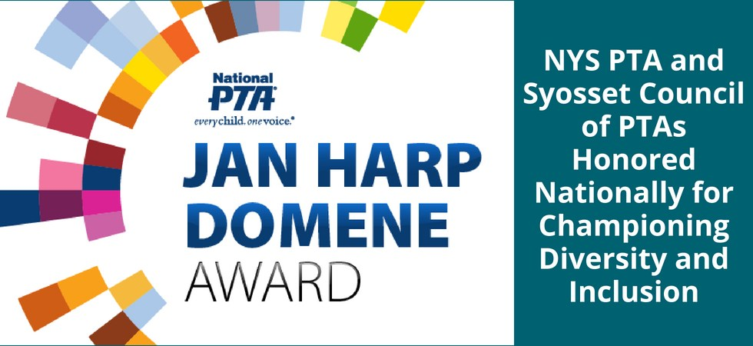
National PTA is pleased to announce the recipients of its 2018 Jan Harp Domene Diversity & Inclusion Award. The award honors one state, one district/council/region and one local PTA for their dedication to making sure the perspectives and needs of all families are represented and supported in the school community. The honorees will be recognized during the 2018 National PTA Convention & Expo in New Orleans, La.
Two of this year’s three recipients are from New York:

New York State PTA
New York State PTA developed and included thorough goals in its strategic plan to create an inclusive environment at all levels of PTA, reflective of the populations the association seeks to serve. As part of this, New York State PTA diversified its Board of Directors and encouraged all PTAs in New York to make sure their Boards of Directors represent their populations as well. Additionally, New York State PTA reached out to schools, administrators and PTAs to encourage diversity and inclusion; conducted meetings, panels and workshops on diversity and inclusion at conferences and events held around the state; implemented social media and web strategies to reflect diversity through content and images; and launched a series of webinars to promote diversity. Among other efforts, New York State PTA testified before the New York State Assembly on supports for English Language Learner students and families and the need for passage of a New York version of the DREAM Act.

Syosset Council of PTAs (Nassau Region)
Among its efforts to promote diversity and inclusion, Syosset Council of PTAs started a “Buddy Program” through which new families in the community are paired with a “buddy” who helps them with language barriers and assists them in navigating school, PTA and class activities. The program has resulted in more diverse membership in the PTA, and parents who do not speak English as well as those from culturally diverse backgrounds are now taking on roles as council delegates, committee chairs, officers and board members in their local units and the council. In addition to the Buddy Program, Syosset Council of PTAs’ Cultural Unity Committee has been meeting with administrators for the school district to offer suggestions to address the needs of the community, including translating publications into at least five languages, translating automated calls from the district, adding Google Translate to district websites and hiring translators for IEP meetings and parent-teacher conferences.
“It is an honor for NYS PTA to be selected as the state recipient of the 2018 Jane Harp Domene Diversity and Inclusion Award,” said Gracemarie Rozea, president of New York State PTA. “We have made great strides during the past year thanks to the hard work of our Governance Team. However, our work is not finished; we look forward to continuing the efforts as we begin our new PTA year. We are very proud of the Syosset Council of PTAs for recognizing the needs in their community. Their well-thought action plan has created an environment that is welcoming and inclusive of all families in their community.”
“Our nation’s children and families have many different talents, backgrounds, opportunities and challenges. It is critical that we recognize, value and embrace the diversity of our communities to create inclusive school environments and ensure that all families feel welcomed, engaged and supported,” said Jim Accomando, president of National PTA. “New York State PTA [and] Syosset Council of PTAs … exemplify what it means to champion diversity and inclusion, and we are thrilled to recognize them with the 2018 Jan Harp Domene Diversity and Inclusion Award.”
The Jan Harp Domene Diversity and Inclusion Award is named after past National PTA President (2007-2009) Jan Harp Domene, who was dedicated to ensuring that families of all backgrounds felt welcomed in PTA and their school communities.
As part of their award, New York State PTA and Syosset Council of PTAs will each receive a $1,000 grant to further their efforts in the areas of diversity and inclusion.
“Diversity and inclusion continue to be of critical importance to NYS PTA. New York has a long and proud tradition of serving a wonderfully diverse population of students, families and educators,” said Kyle McCauley Belokopitsky, Esq., New York State PTA executive director. “We stand tall, committed to this work, and I am so proud of the work that NYS PTA has accomplished these past years.”
“PTAs are uniquely qualified to address and honor the diversity of our communities and play an important role in helping ensure that all families are equipped with the tools to support their child and improve the school,” added Nathan R. Monell, CAE, National PTA executive director. “When we are truly inclusive, we are an even more powerful voice for making every child’s potential a reality.”

